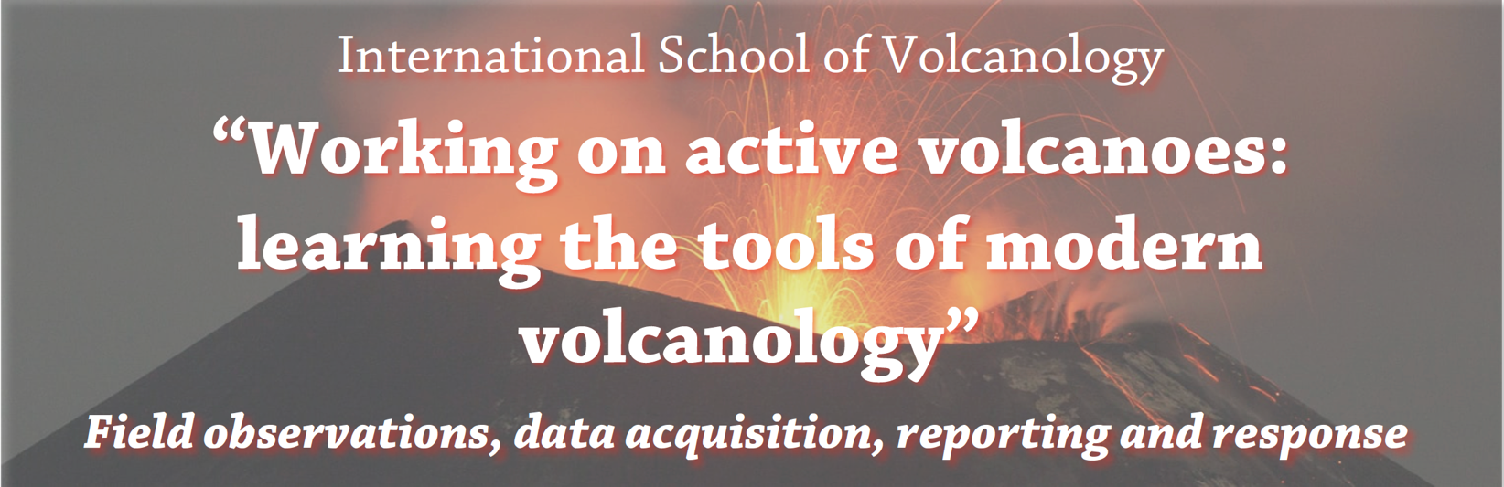

15 June – 23 June, 2024: Lipari, Vulcano and Stromboli (Aeolian Islands, Italy)

Application Form
To be e-mailed (as part of the completed application package)
by midnight (CET) 20 February 2024 to: school@aivulc.it

First name: …………………..……………..……………. Last name: …………………………………….…………..…………………………

Affiliation: ……………………………………….…………………………………………………………………………………………………………

Address: ………………….…………………………………………………………………………………..................................................

e-mail: ………………….………………………………….

Position: MSc Final Year ⁭ PhD ⁭ post-Doc ⁭ Other …………………………………………..

Application items
Please also attach to the email:

(i) a statement of interest / letter stating why participation at the school is of relevance to your current and future needs (max. 1 page); (ii) a short, current Curriculum Vitae (max. 1 page); (iii) a statement of health and fitness (auto evaluation – no need a medical certificate).

The school organization is covering accommodation during the school (8 nights), as well as breakfast and evening meals, plus boat and bus fares. It is NOT covering AIV Membership (€ 15.00), travel expenses and any costs incurred along the way, to and from Lipari, and daily lunches (picnic).

The official language is English.

Only a limited number of places will be available, where places will be assigned based on the quality and relevance of the applications (see second circular).

Important note
Should pre-registration requests exceed the 20 places available, the organising committee will make a selection on the basis of the selection criteria (quality and relevance of the application).

Confirmation of acceptance and admittance to the school is dependent on submitting the full application package to school@aivulc.it by midnight (CET) of 20 February 2024. AIV membership payment (€15) is due by 20 May 2024.

Legal disclaimer
Personal data will be processed by AIV for organizational purposes only and in accordance with Italian legislation on privacy (DdL 196/03). It will not be released to third parties.

Signature …………….…………………………… Date: …………………………………………...

